**A**

**Project Report**

**On**

Second-Hand Book Store

**Submitted by**

Mr. / Ms. Lagad Shubham Sambhaji

Roll No.: 21431

Class: **MCA- I**

**Guided by**

Prof. Rahul Navale

**For the Academic Year 2021-22**



Sinhgad Technical Education Society’s

SINHGAD INSTITUTE OF MANAGEMENT,

Vadgaon Bk, Pune

(Affiliated to Savitribai Phule Pune University, Approved by AICTE & Accredited by National Board of Accreditation, New Delhi).

**CERTIFICATE**

This is to certify that Mr. **Lagad Shubham Sambhaji**, has successfully completed his project work entitled **“Second-Hand Book Store”** in partial fulfillment of MCA-I SEM-I Mini Project for the year 2021-2022. He have worked under our guidance and direction.

**Prof. Rahul Navale Dr. Chandrani Singh**

**Project Guide Director, SIOM-MCA**

**Examiner 1 Examiner 2**

**Date:**

**Place:**

**DECLARATION**

We certify that the work contained in this report is original and has been done by us under the guidance of my supervisor(s).

* The work has not been submitted to any other Institute for any degree or diploma.
* We have followed the guidelines provided by the Institute in preparing the report.
* We have conformed to the norms and guidelines given in the Ethical Code of Conduct of the Institute.
* Whenever we have used materials (data, theoretical analysis, figures, and text) from other sources, we have given due credit to them by citing them in the text of the report and giving their details in the references.

**Name and Signature of Project Team Members:**

|  |  |  |  |
| --- | --- | --- | --- |
| **Sr. No.** | **Seat No.** | **Name of students** | **Signature of students** |
| **1** | **20127** | **Lagad Shubham Sambhaji** |  |

**ACKNOWLEDGEMENT**

We have immense pleasure in expressing our sincerest and deepest sense of gratitude towards our guide **Mr. Prof. Rahul Navale** for the assistance, valuable guidance and co- operation in carrying out this Project successfully. We have developed this project with the help of Faculty members of our institute and we are extremely grateful to all of them. We also take this opportunity to thank Head of the Department Dr. Chandrani Singh, for providing the required facilities in completing this project. We are greatly thankful to our parents, friends and faculty members for their motivation, guidance and help whenever needed.

**Thank You,**

**Student Name: Lagad Shubham Sambhaji**

|  |  |  |
| --- | --- | --- |
| **Index** | | |
| **Sr. No.** | **Topic** | **Page No.** |
| **1** | **INTRODUCTION** | 06 |
| 1.1 | Existing System and Need for System | 07 |
| 1.2 | Scope of Work | 09 |
| 1.3 | Operating Environment - Hardware and Software | 10 |
| **2** | **PROPOSED** **SYSTEM** |  |
| 2.1 | Proposed System (Introduction of system) | 11 |
| 2.2 | Module specifications (Scope) | 13 |
| 2.3 | Objectives of System | 16 |
| **3** | **ANALYSIS & DESIGN** |  |
| 3.1 | Class Diagram | 17 |
| 3.2 | Object Diagram | 18 |
| 3.3 | Component Diagram | 18 |
| 3.4 | Deployment Diagram | 19 |
| 3.5 | Use Case Diagrams | 20 |
| 3.6 | Activity Diagram | 21 |
| 3.7 | Sequence Diagram | 22 |
| 3.8 | Collaboration Diagram | 23 |
| 3.9 | State Chart Diagram | 24 |
| 3.10 | Table specifications (Database design) | 25 |
| **4** | **USER MANUAL** |  |
| 4.1 | User Interface Screens with data (Input/ Output) | 29 |
| 4.2 | Sample program code | 37 |
| 4.3 | Limitations and Bibliography | 49 |

**Introduction**

This project is like an Online bookstore website where books can be bought from the comfort of home through the Internet. An **Online Second-Hand Book Store** is a virtual store on the Internet where customers can browse the catalogue and select books of interest. User can select many books and those books stored in cart. At checkout time, the items in the shopping cart will be presented as an order. At that time, more information will be needed to complete the transaction. Usually, the customer will be asked to fill the basic details or select a billing address, a shipping address, a shipping option, and payment information such as credit card number.

**Existing System and Need for System**

* **Existing System** 
  1. Lack of touch and feel in shopping.
  2. Lack of interactivity between buyer and seller in shopping
  3. In existing system there has no option to selling or buying old books.
  4. In Existing System the Customer is completely depending on the manual process for buying the products.
  5. Manual process is a time consuming factor. And when customer approaches for a manual shopping directly, actually he/she does not have an idea about things like, price range, items, etc.,
  6. The time which has been spent by the customer in manual shopping can equates to multiple number of shopping. As customer can sit at home and browse in a fraction of seconds.

* **Need for System**

Students have many course-based literature text books that they have stopped reading and these books are laying on their book shelves unused and also Suppose a student had completed his academic year he has some books that he wants to be sold they can easily be sold his books using this site. These books can be sold and the proceeds can be used to buy another book the student currently needs. This website will not only serve students but can also serve the entire population or anybody who wants to buy second hand books or wants to empty their book shelves and make financial gain from it. These books can just be simply be uploaded to the website and another student or person can have access to buy the book by just visiting the website. Students also have lesser incomes compared to the rest of the working population. Hence any reasonable resource for getting income is always welcomed. All these will be achieved by creating a user friendly complete online shopping system for buying and selling second-hand books

**Scope of Work**

Online Book Store carrying out the traditional selling process in an electronic form, using the internet. An object of the present invention to provide an electronic reselling system that reduces the amount of money spend, and at the same time, that identifies the real users who needs the book and have offered the contract price, and moreover, to gain revenue to the Original Book seller.

Online stores are usually available 24 hours a day, and many consumers have Internet access both at work and at home.

Searching or browsing an online catalog can be faster than browsing the physical store.

**Operating Environment - Hardware and Software**

* **Server side requirement** 
  + Hardware Requirements
    - * Processor : Intel core i3 and above
      * RAM : 1 GB
      * HDD: 120GB
  + Software Requirements :
    - * Operating System : Windows 10
      * Database : MYSQL
      * Front End : HTML, JavaScript
      * Server Side Script : JSP
      * Software Development Tool : Visual Studio Code
* **Client side requirement**

o Hardware Requirements:

* + - * + Processor : Intel core i3
        + RAM : 1 GB
        + HDD: 120GB

o Software Requirements:

* + - * + Operating System : Windows 10
        + Browser : Google Chrome

## Proposed System

* Customers can get their book delivered instead of actually going and buying or selling the book.
* A user can sell their second-hand books easily.
* Feasibility of making payment online itself.
* Managing of inventory of the books for user becomes easier as customers are not visiting and ordering it online.
* This system saves both time and travelling cost of customers or also he get more earning.

## Feasibility Study

* **Technical Feasibility**
* The technical feasibility study basically centers on alternatives for hare software and design approach to determine the functional aspects of system.
* This project on Online Second-Hand Book Store will be platform independent since it is coded in JAVA language (using JavaScript and CSS).

HTML is used to create pages and JSP for handling data.

* MySQL database will be used for storing data.
* Hardware requirements are compatible with all Operating System Only author person will be able to use the website so it would be secure the system can be expanded as per the needs of requirement specification.

* Technical feasibility is concerned with specifying equipment and software that will meets the equipment and goals.
* The analyst must find out whether current technical resource can be upgraded or
* Added to in manner that fulfils the request under consideration.
* The system must be evaluated from the technical point of view first.
* The assessment of this feasibility must be based on an outline design of the system
* Requirement in the terms of input, output, programs and procedures.

* **Economic Feasibility**
* A system can be developed technically and that will be if installed it must still be a good investment for the organization.
* Financial benefits must equal or exceed the costs. It is the most frequently used evaluating the effectiveness of proposed system, more commonly known as Benefit analysis.
* Benefit analysis is to determine benefits and savings which are expected from candidate system and compare them with cost. If the benefits are more than the cost, the decision is made to design and implement the system.
* The cost and benefits may be direct or indirect and tangible or intangible.

* **Operational Feasibility**
* Operational Feasibility is a measure of how people are able to work with system. This type of feasibility demands if the system will work when developed and installed.
* Some of the important issues raised during operational feasibility are that
* Will the system be used and work properly if it is being developed and implemented?
* Is there sufficient support for the management from the user?
* Since the website is very user friendly so users will find it comfortable to work on this site.

**Module specifications**

**Modules:**

* **User:** 
  1. Registration
  2. Login
  3. View Books
  4. Buy Books
  5. Upload Books
  6. Delete Books
  7. My Orders
  8. Cancel Order
  9. Payment
  10. View Buyer
  11. My Cart
  12. Update Profile
  13. Change Password
* **Admin**:
  1. Login
  2. View Books
  3. View Orders
  4. View User

**Functionalities:**

* **User:** 
  1. **Registration**: User need to register first with their basic registration details and nee to create a valid login id and password.
  2. **Login**: Using valid login credentials, user need to login into the system in order to access the system.
  3. **View** **Books**: Once user is logged into the, he/she may view all the added/uploaded books with their details.
  4. **Buy** **Books**: User can surf various book of their choice and buy them.
  5. **Upload** **Books**: System allows user to sell their books online buy added the book name and its details.
  6. **Delete Uploaded Book** : User can delete uploaded book by giving specific reasons.
  7. **My** **Orders**: All the purchase history of user will be displayed with details.
  8. **Payment** : User can do payment for their orders.
  9. **View** **Buyer**: If any buyer is interested in buying a book or anyone buys a book from the user then buyer’s details will be displayed.
  10. **Cancel Order** : User can cancel their orders.
  11. **Update Profile** : User can update their profile.
  12. **My Cart** : User can add book to his cart.
  13. **Change Password** : User can change their account password.

* **Admin**:
  1. **Login**: Using valid login credentials, admin need to login into the system in order to access the system.
  2. **View** **Books**: Admin can view all the added books online with their details.
  3. **View** **Orders**: System allows admin to view all the orders details of buying and selling a book.
  4. **View** **User**: All the registered user details will be displayed to the admin

## Objectives of System

The major goal for Online Second-Hand Book Store that in future people, especially students should have an easy way to buy and sell secondhand books online. The user can earn more money using selling his secondhand books. The users will be able to carry out all these in a secured and managed environment. The second-hand Book shop shall be easy to navigate and user friendly and easy to find books in various categories. It shall be easy to administer and handling of orders and sales processes shall be easy to handle by the administrator

**ANALYSIS & DESIGN**

**Class Diagram :**

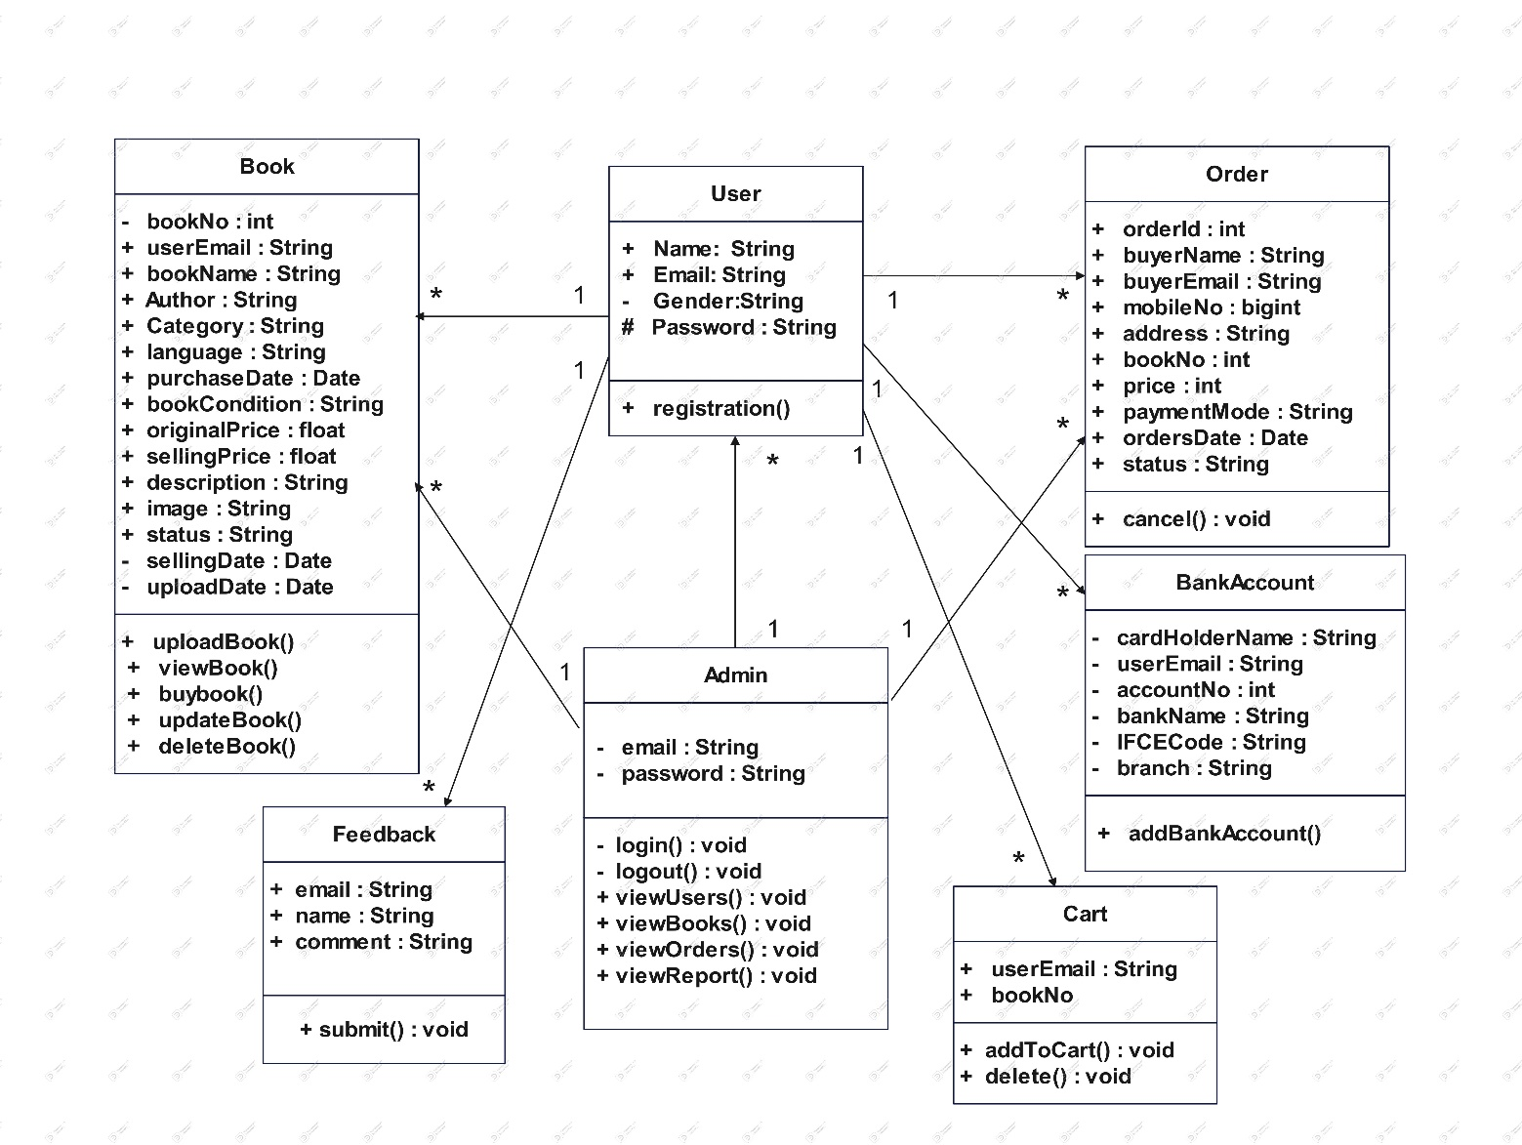

**Object Diagram :**

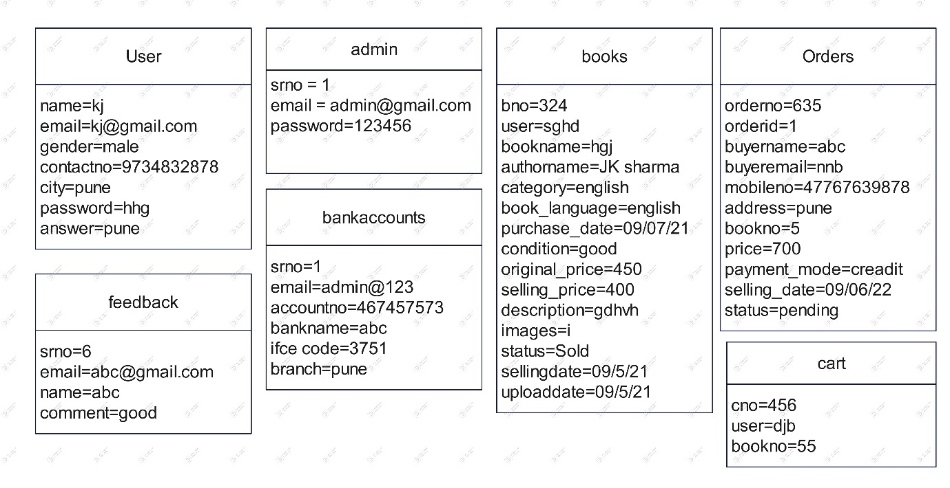

**Component Diagram :**

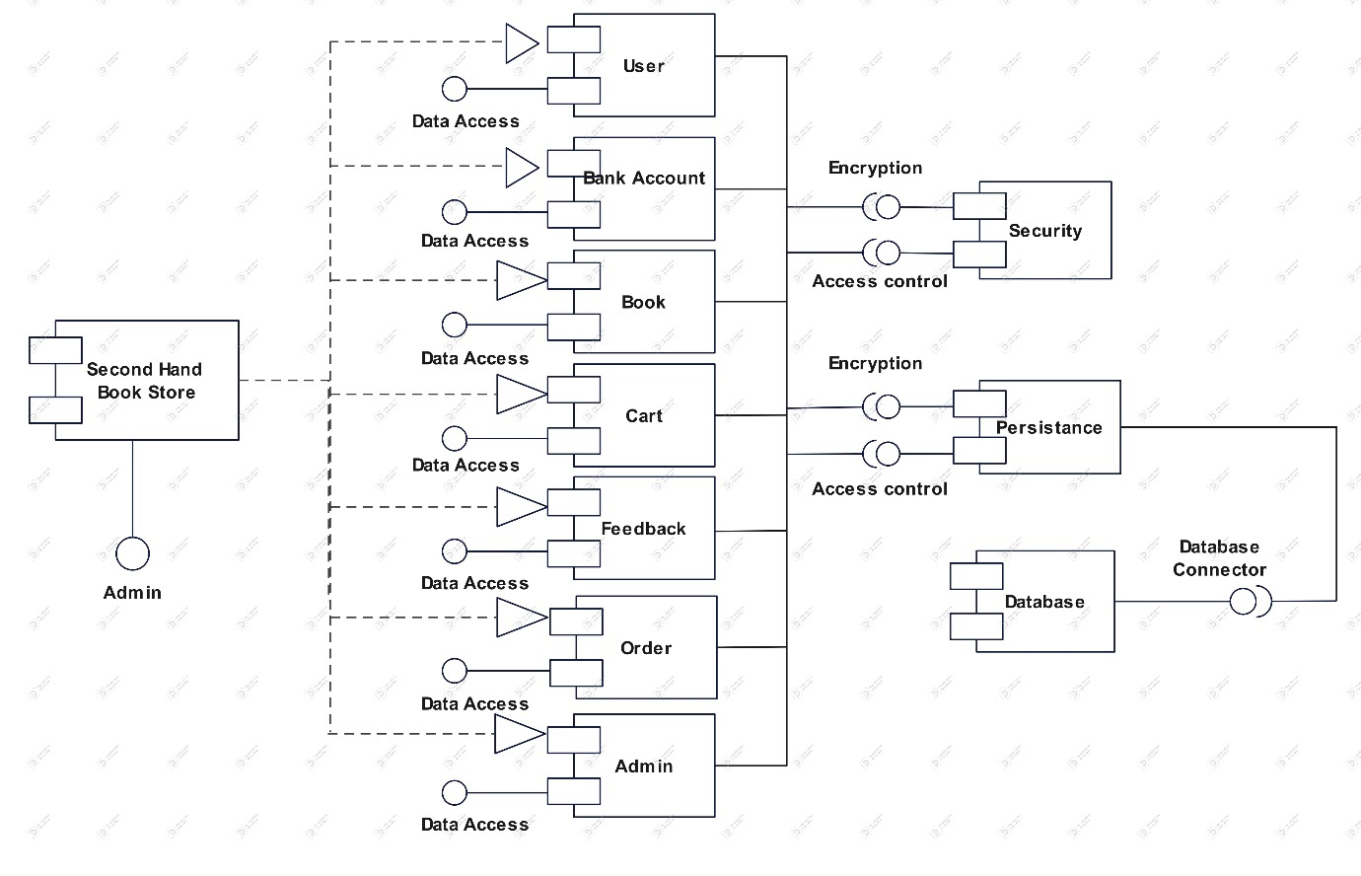

**Deployment Diagram :**

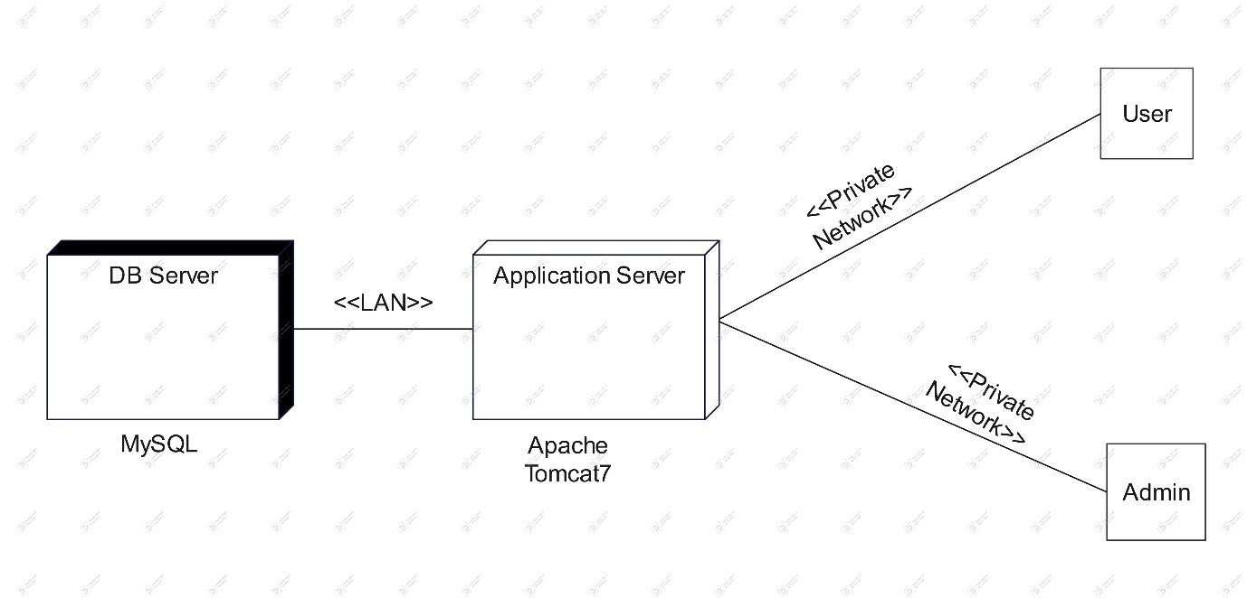

**Use Case Diagrams :**

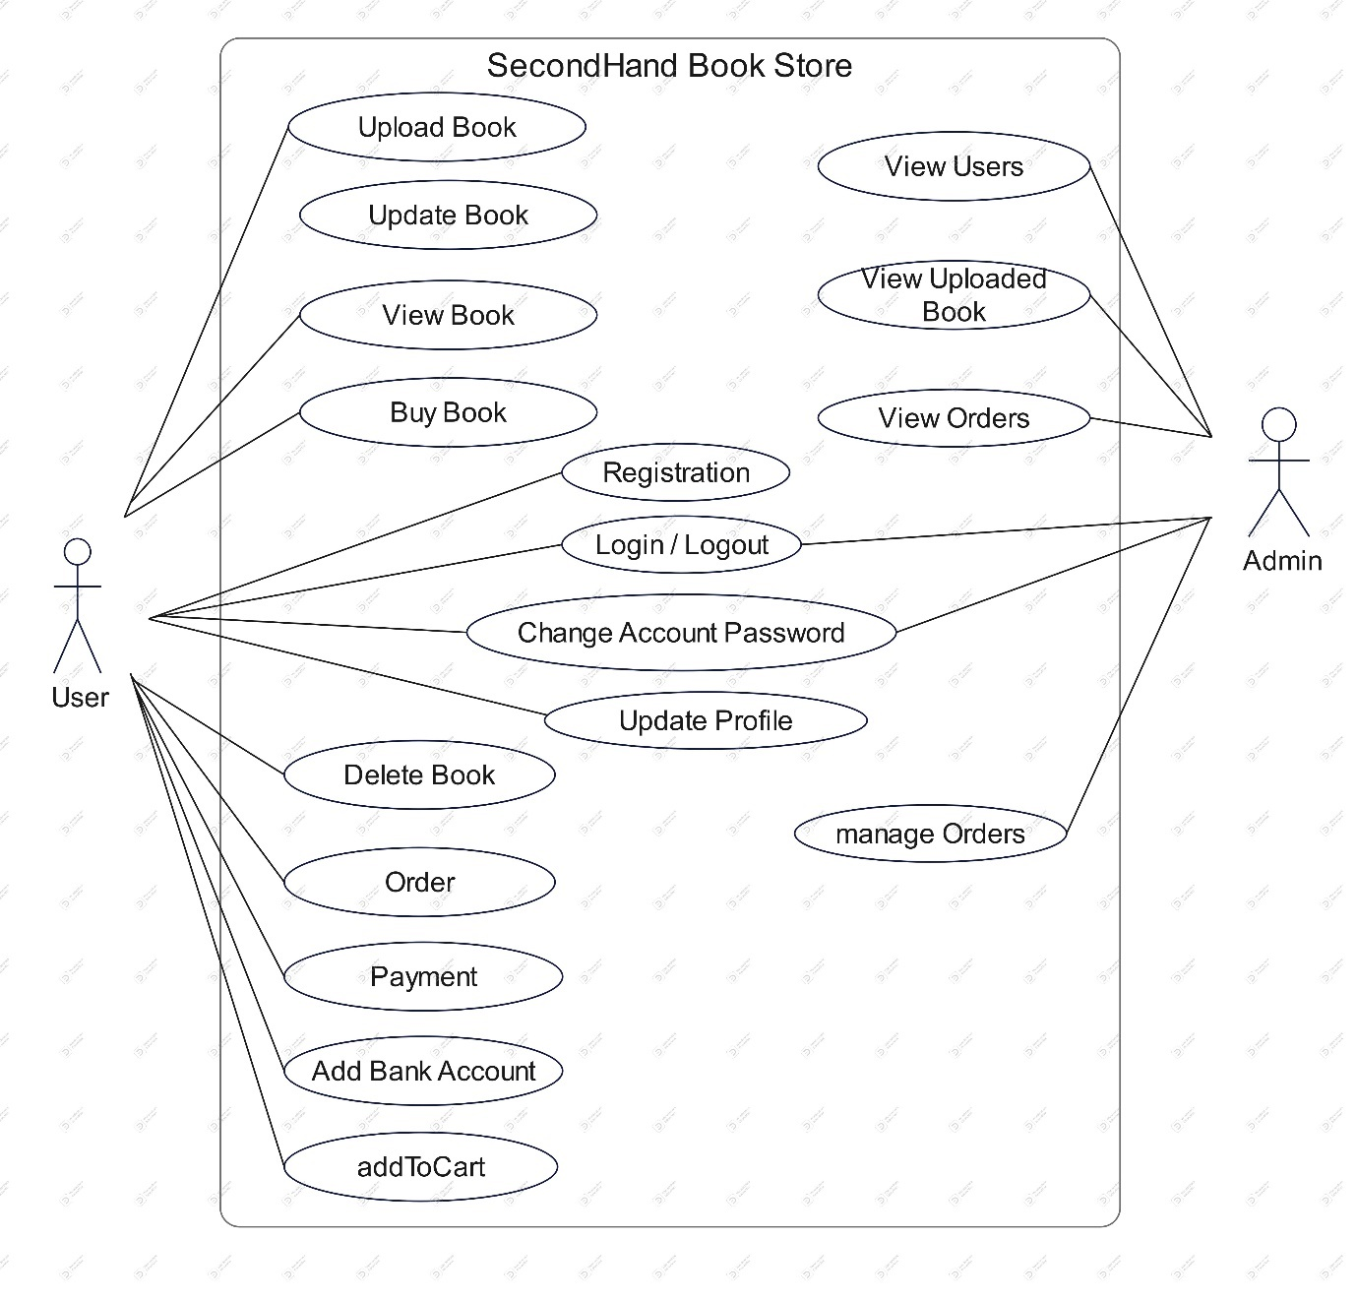

**Activity Diagram :**

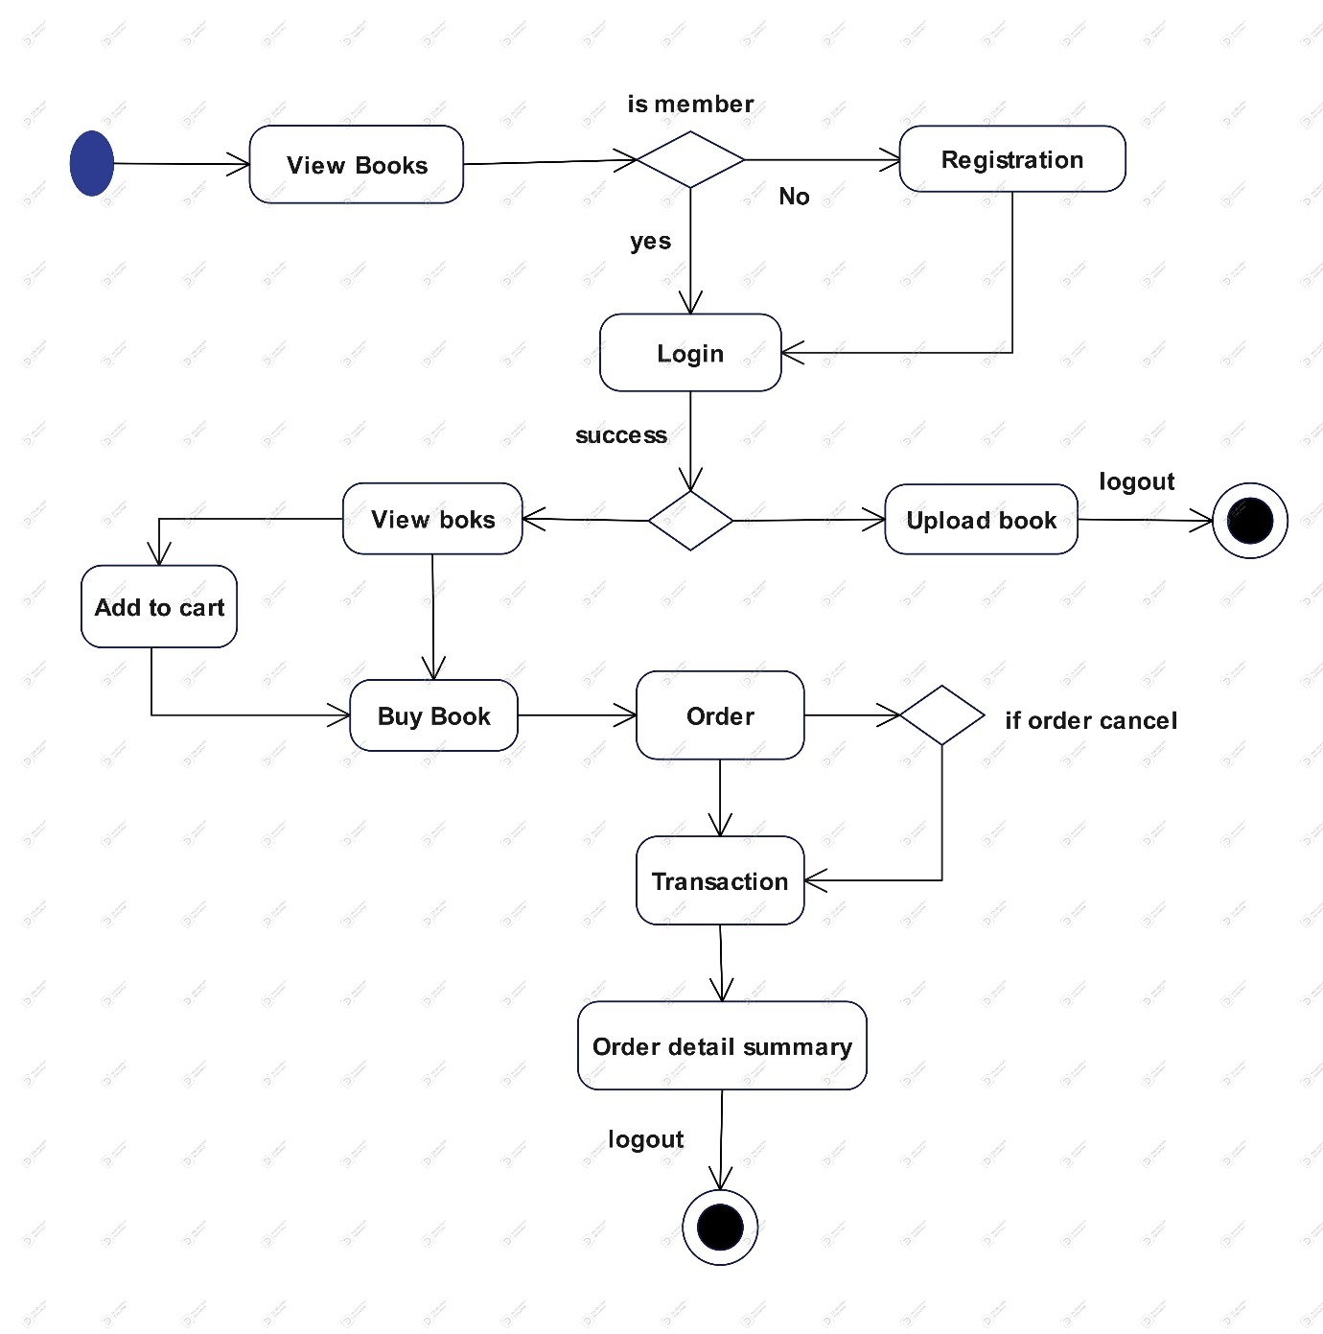

**Sequence Diagram :**

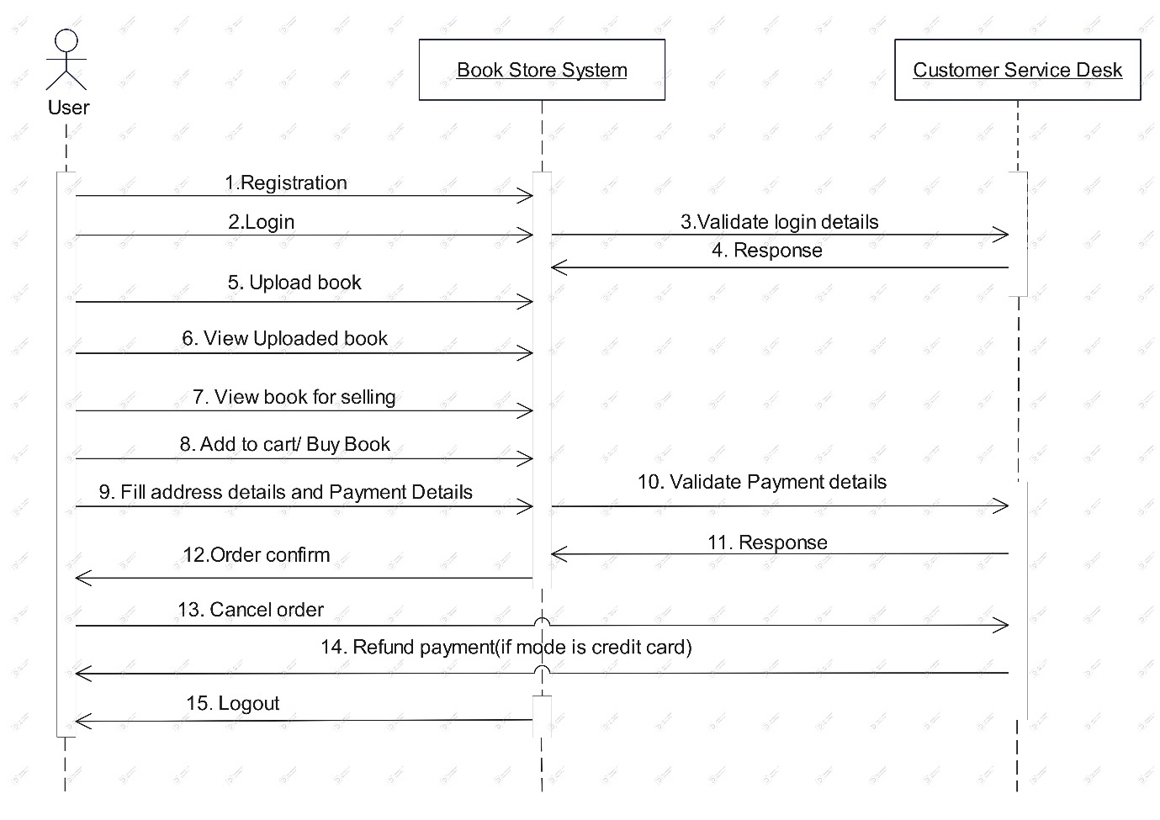

**Collaboration Diagram :**

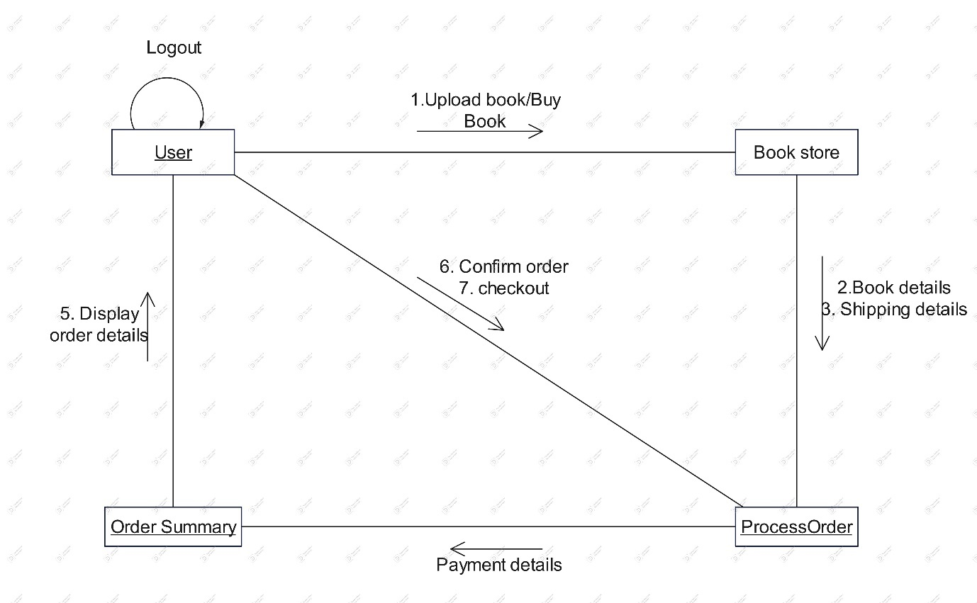

**State Chart Diagram :**

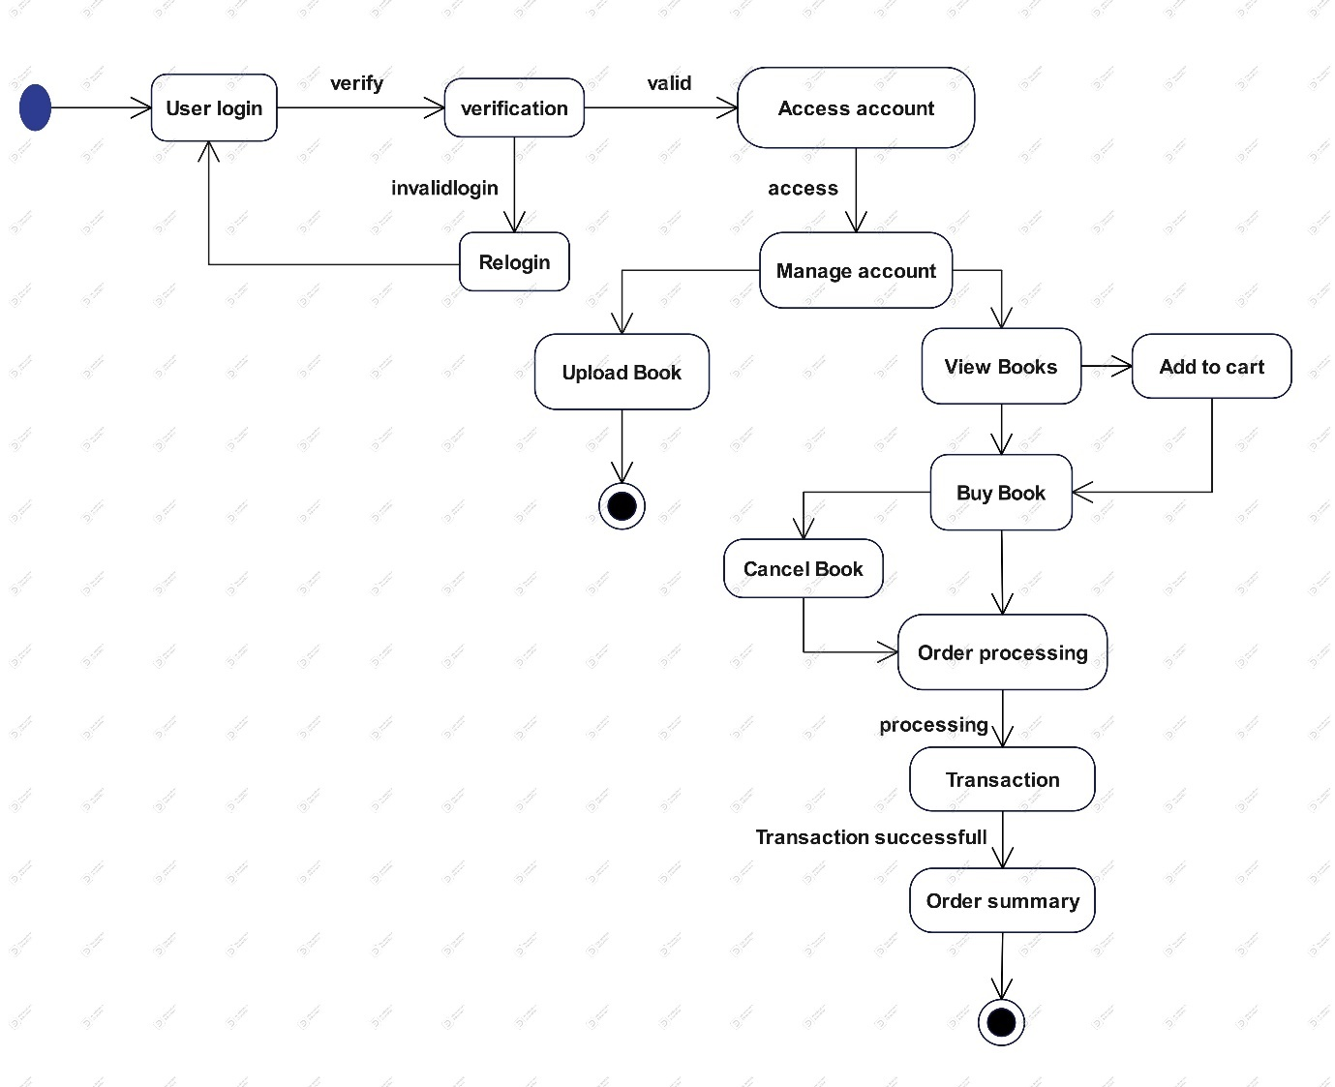

**Table specifications :**

**Table Name: Admin**

|  |  |  |
| --- | --- | --- |
| **Column Name** | **Data Type** | **Constraint** |
| Srno | Int (11) | Primary Key |
| Email | varchar (50) | Not Null |
| Password | varchar (8) | Not Null |

**Table Name: Users**

|  |  |  |
| --- | --- | --- |
| **Column Name** | **Data Type** | **Constraint** |
| Name | Varchar (30) | NOT NULL |
| Email | Varchar (50) | Primary Key |
| Gender | Varchar (8) | NOT NULL |
| Contact No | Varchar (10) | NOT NULL |
| City | Varchar (20) | NOT NULL |
| Password | Varchar (8) | NOT NULL |
| Answer | Varchar (20) | NOT NULL |

**Table Name:** **Books**

|  |  |  |
| --- | --- | --- |
| **Column Name** | **Data Type** | **Constraint** |
| Bno | Int (11) | Primary Key |
| User | Varchar (50) | Foreign Key |
| Book Name | Varchar (50) | NOT NULL |
| Author Name | Varchar (30) | NOT NULL |
| Category | Varchar (20) | NOT NULL |
| Book Language | Varchar (8) | NOT NULL |
| Purchase date | date | NOT NULL |
| Book Condition | Varchar (5) | NOT NULL |
| Original Price | float | NOT NULL |
| Selling Price | float | NOT NULL |
| Description | Varchar (50) | NOT NULL |
| Image | Varchar (30) | NOT NULL |
| Status | Varchar (15) | NOT NULL |
| Selling date | date | NOT NULL |
| Upload date | date | NOT NULL |

**Table Name: Orders**

|  |  |  |
| --- | --- | --- |
| **Column Name** | **Data Type** | **Constraint** |
| Order No | Int (11) | Primary Key |
| Order ID | Varchar (12) | NOT NULL |
| Buyer Name | Varchar (30) | NOT NULL |
| Buyer Email | Varchar (50) | NOT NULL |
| Mobile No | Varchar (10) | NOT NULL |
| Address | text | NOT NULL |
| Book No | Int (11) | Foreign Key |
| Price | float | NOT NULL |
| Payment Mode | Varchar (20) | NOT NULL |
| Selling date | date | NOT NULL |
| Status | Varchar (20) | NOT NULL |

**Table Name: Bankaccounts**

|  |  |  |
| --- | --- | --- |
| **Column** | **Data Type** | **Constraint** |
| Srno | Int (11)1 | Primary Key |
| Name | Varchar (30) | NOT NULL |
| Email | Varchar (50) | Foreign Key |
| Account No | Varchar (20) | NOT NULL |
| Bank Name | Varchar (50) | NOT NULL |
| IFCE Code | Varchar (15) | NOT NULL |
| Branch | Varchar (30) | NOT NULL |

**Table Name: Cart**

|  |  |  |
| --- | --- | --- |
| **Column Name** | **Data Type** | **Constraint** |
| Cno | Int (11) | Primary Key |
| User | Varchar (50) | Foreign Key |
| Book No | Int(11) | Foreign Key |

**Table Name: Feedbacks**

|  |  |  |
| --- | --- | --- |
| Column Name | Data Type | Constraint |
| Srno | Int (11) | Primary Key |
| Email | Varchar (50) | Foreign Key |
| Name | Varchar (30) | NOT NULL |
| Comment | text | NOT NULL |

**USER MANUAL**

**User Interface Screens with data (Input/ Output) :**

**Index.jsp**

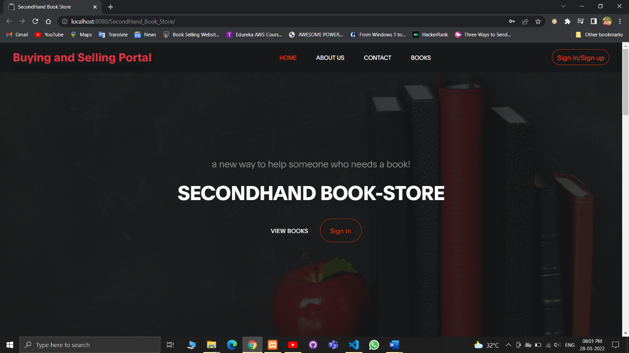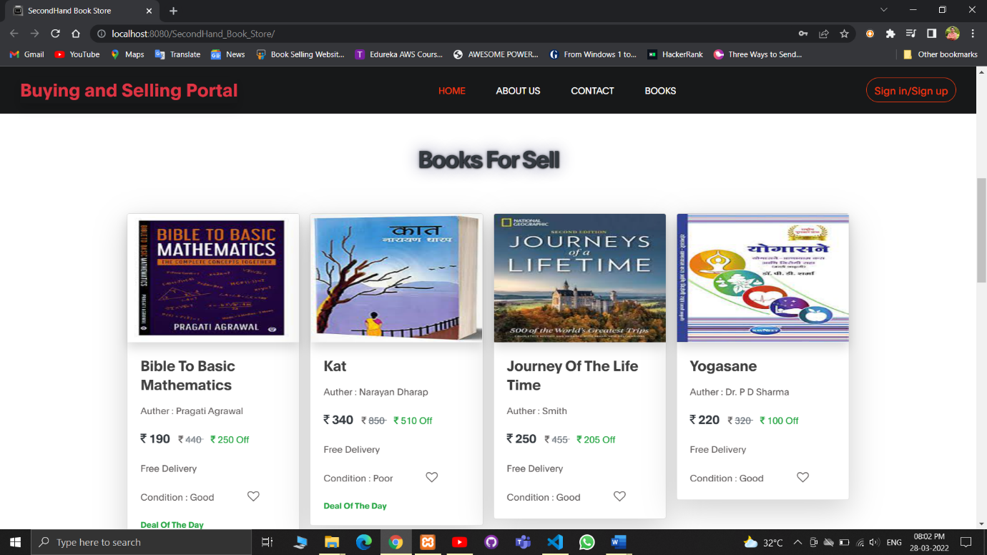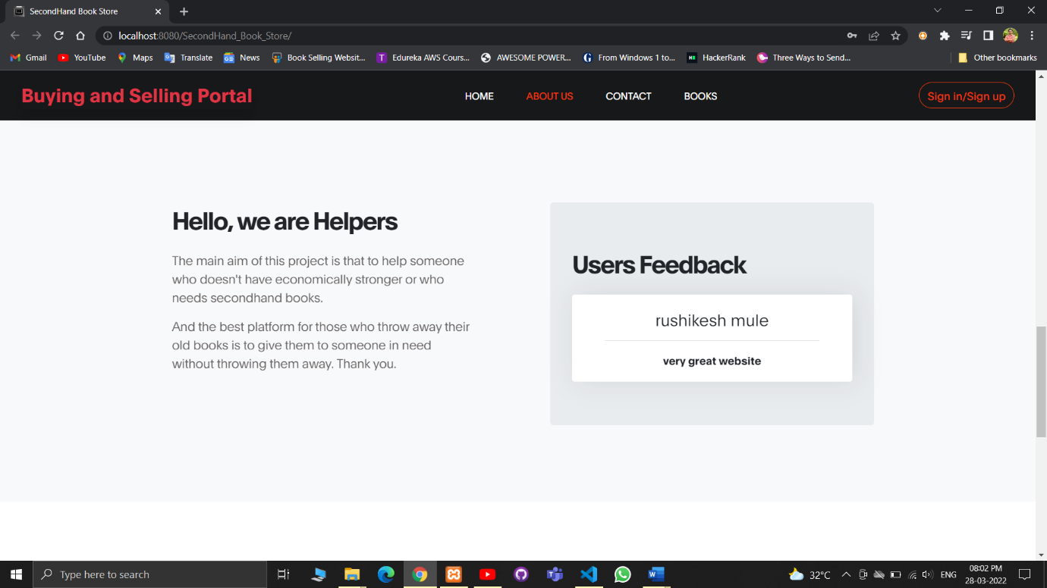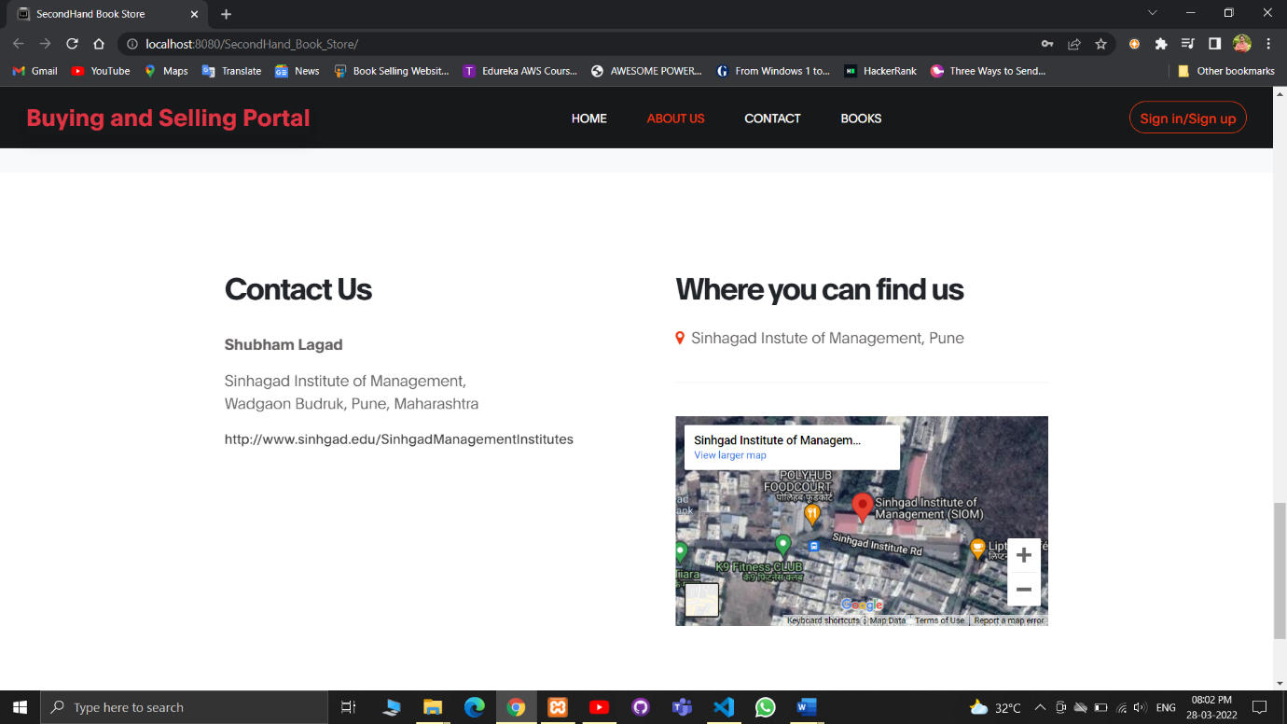

**Login model**

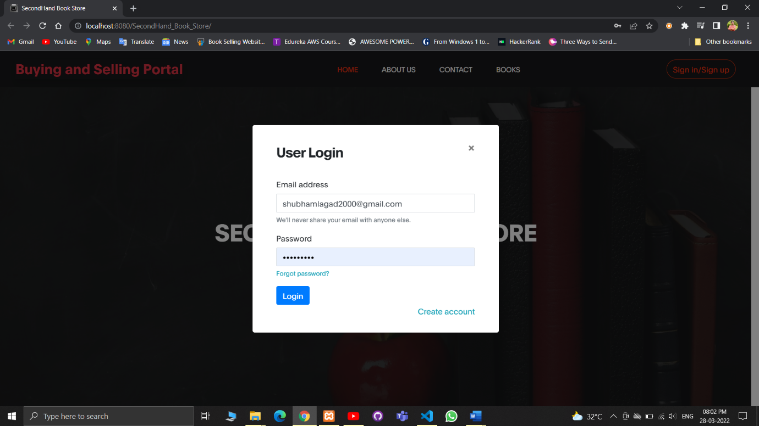

**Registration model**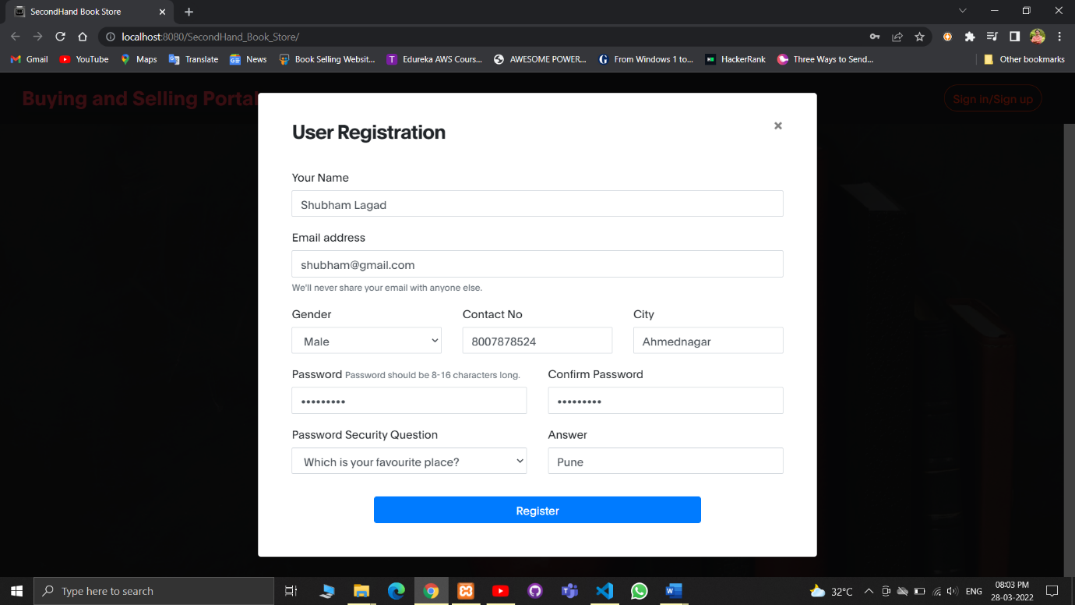

**userIndex.jsp**

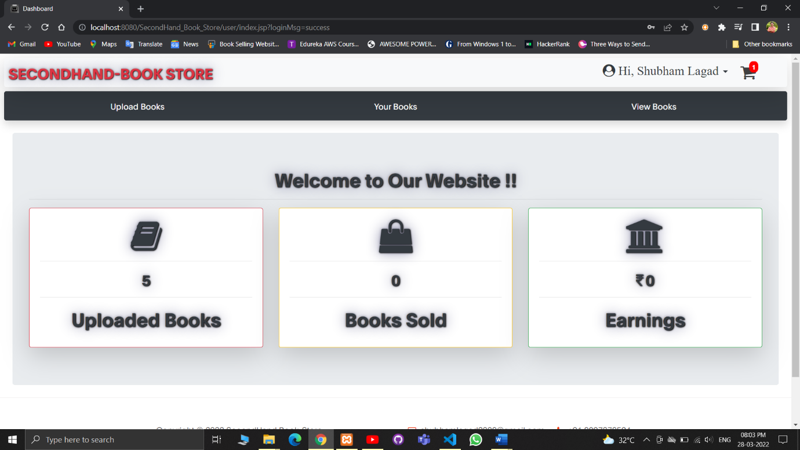

**uploadBook.jsp**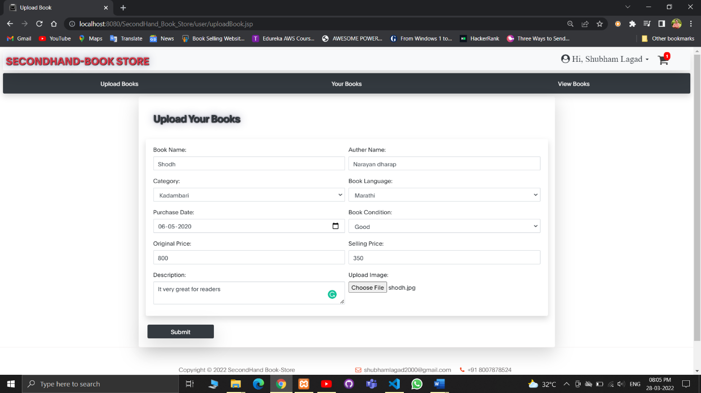

myBooks.jsp

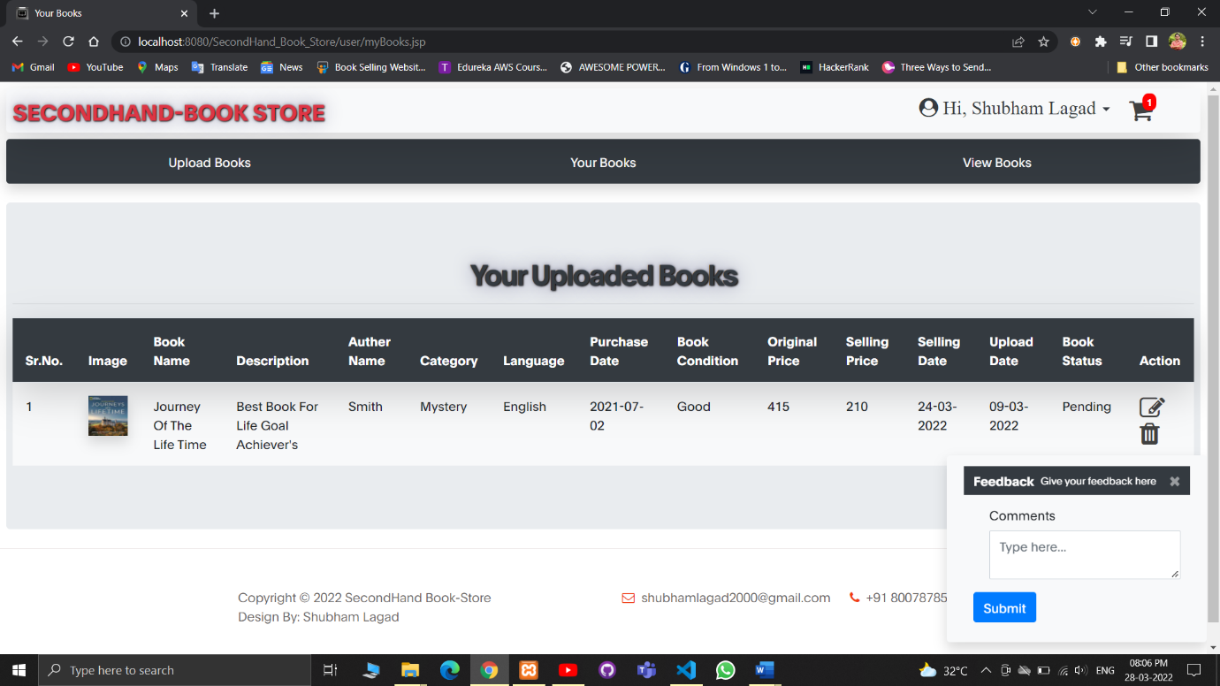

**viewBooks.jsp**

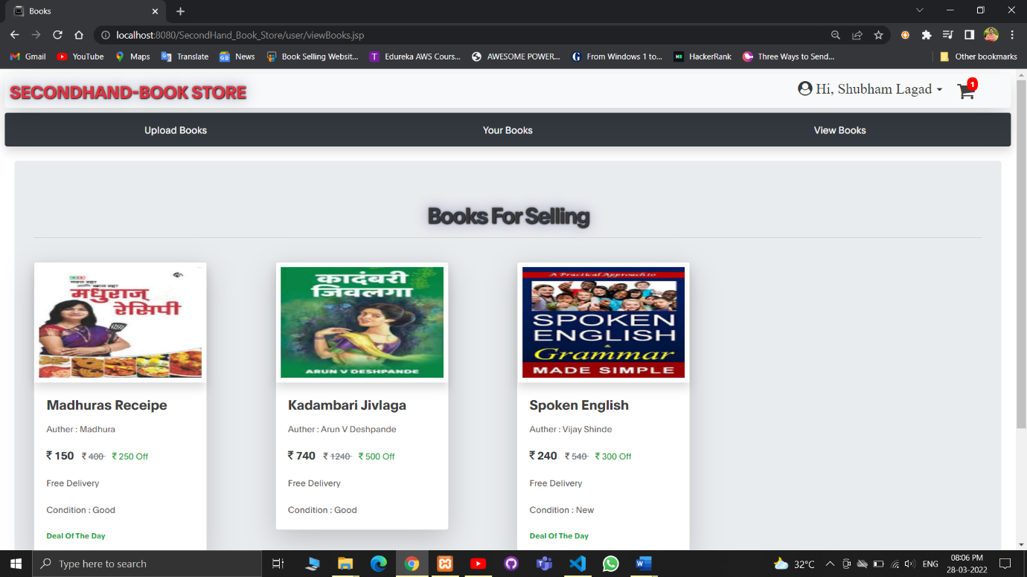

**viewSingleBook.jsp**

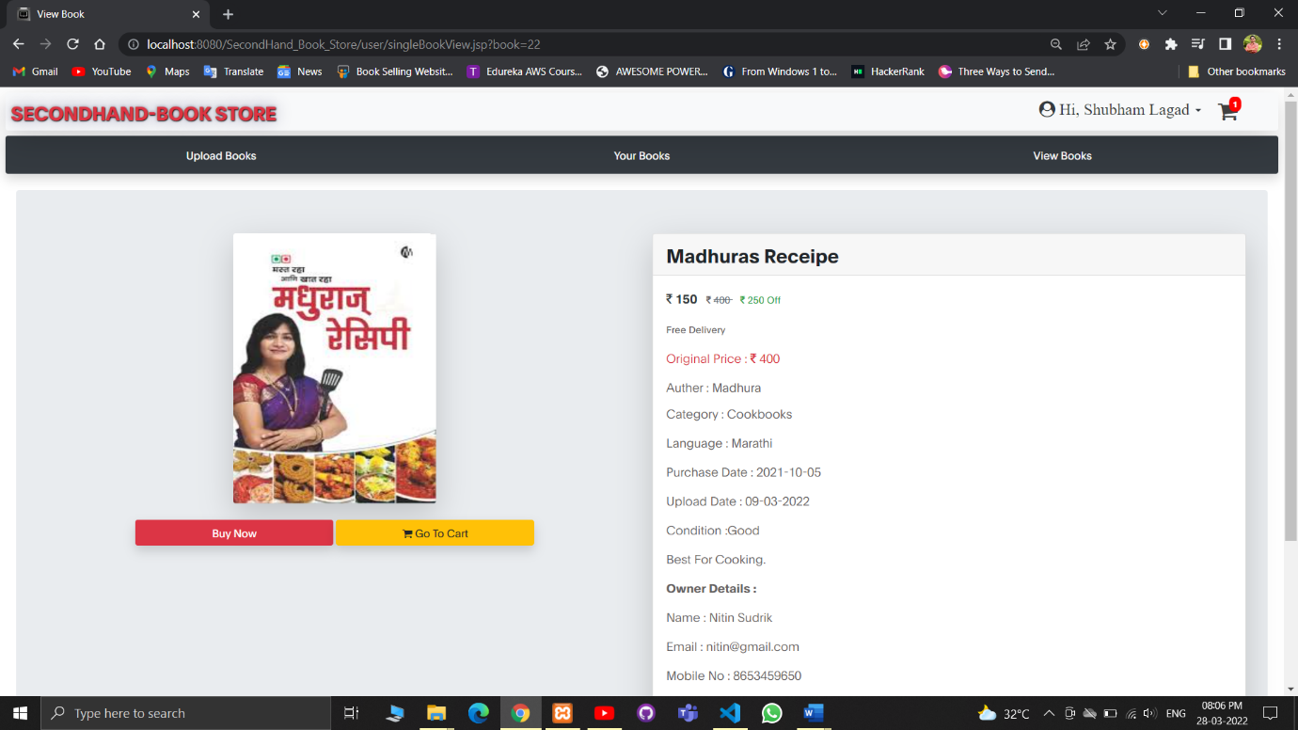

**myCart.jsp**

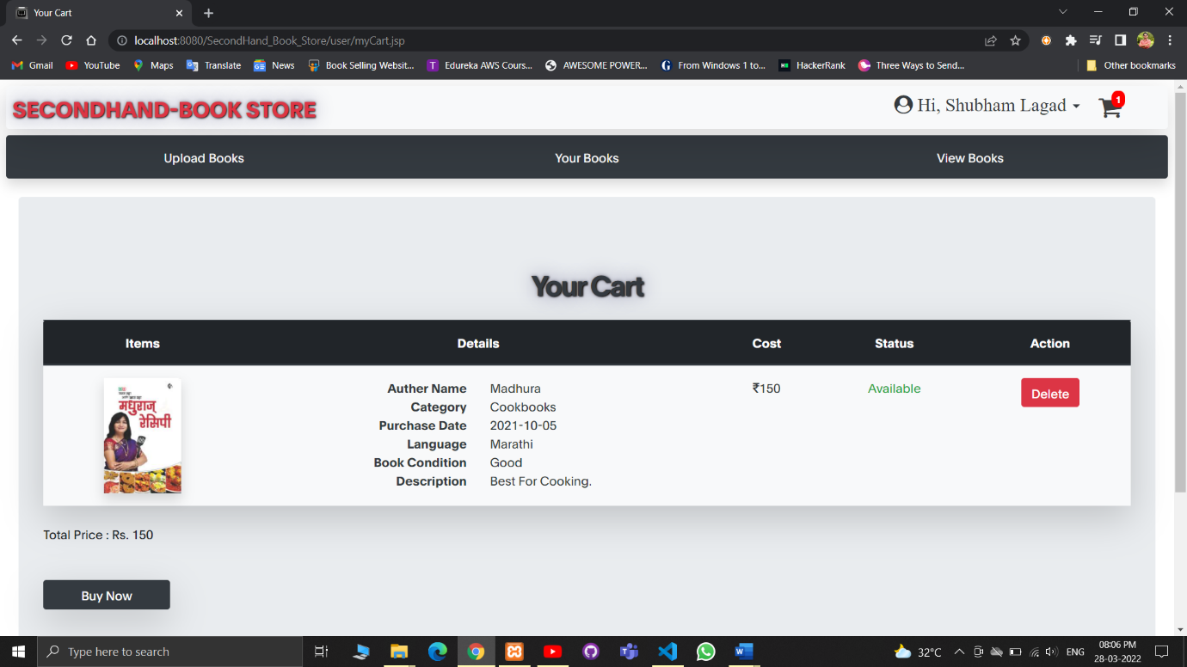

**orderConfirmed.jsp**

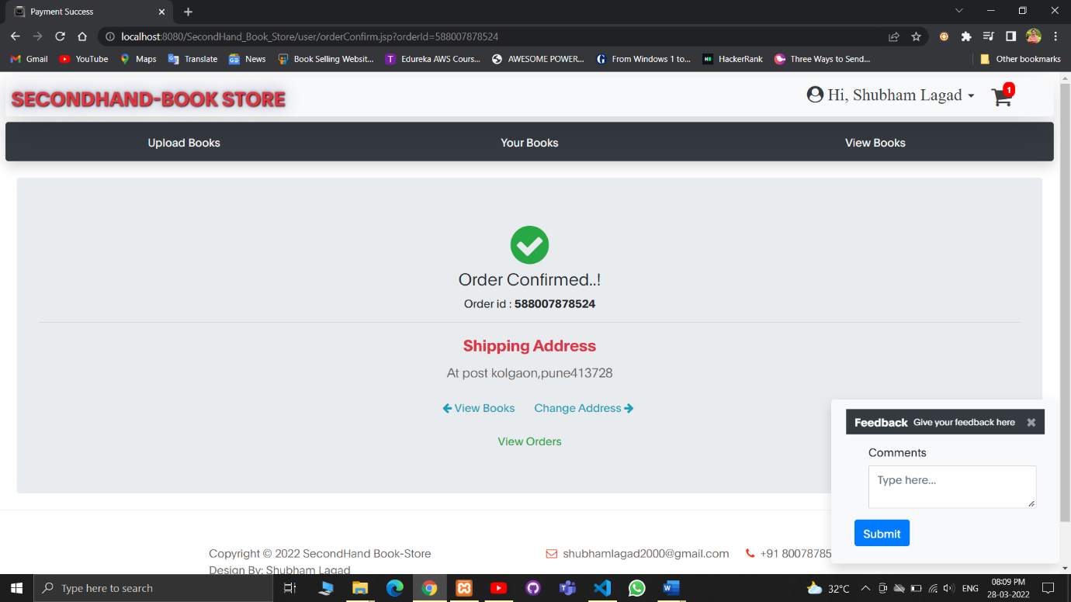

**myOrders.jsp**

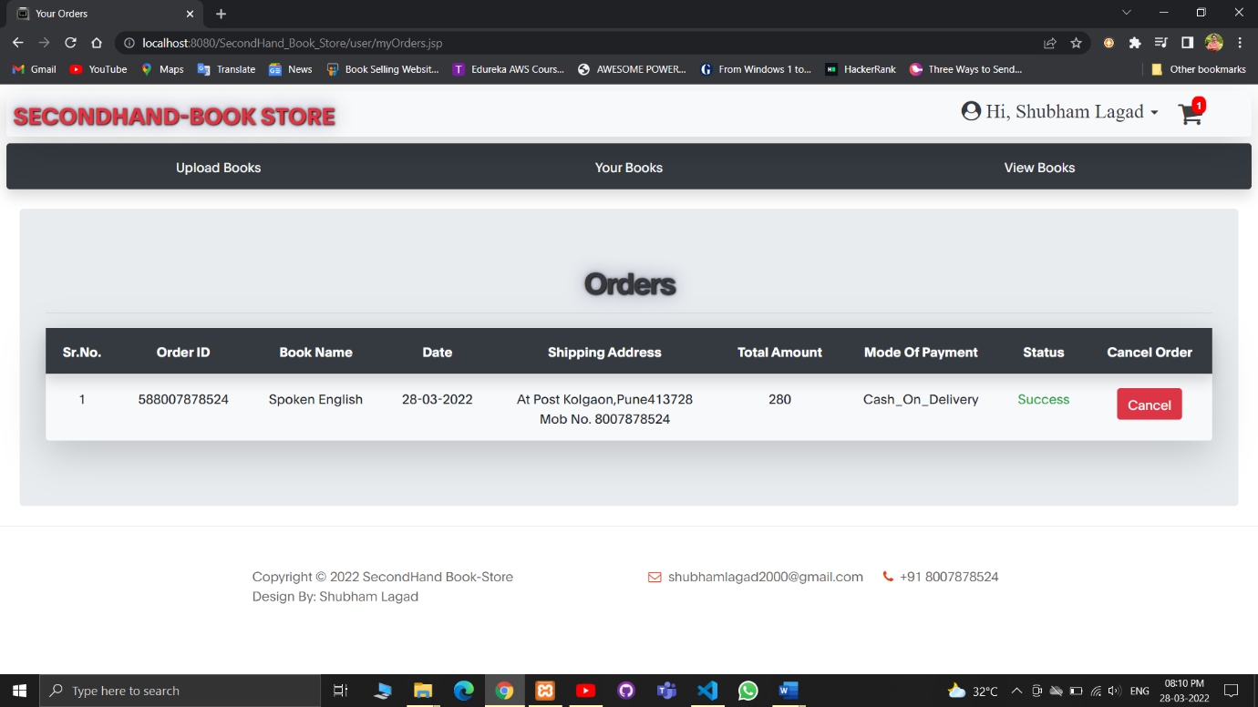

**changePassword.jsp**

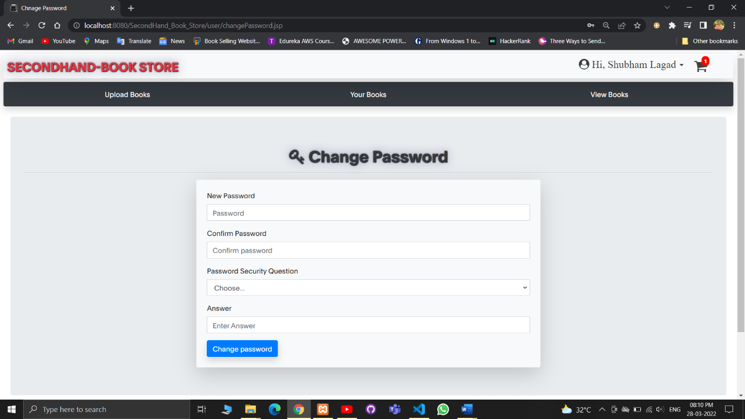

**addBankAccount.jsp**

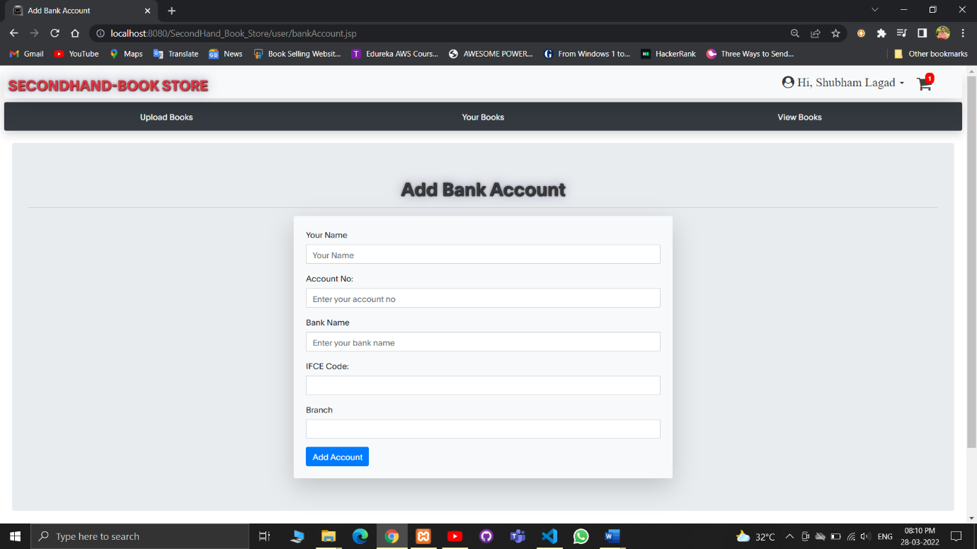

**Sample program code**

**Connection.jsp :**

**<%--**

**Document : connect**

**Created on : 31-Jan-2022, 7:06:46 pm**

**Author : shubh**

**--%>**

**<%@page contentType="text/html" pageEncoding="UTF-8"%>**

**<%@ page import="java.sql.*"%>**

**<%@ page import="java.util.*" %>**

**<%**

**Connection connection = null;**

**try {**

**//Class.forName("com.mysql.jdbc.Driver"); This is deprecated**

**Class.forName("com.mysql.cj.jdbc.Driver");**

**connection = DriverManager.getConnection("jdbc:mysql://localhost:3306/secondhand_book", "root", "");**

**String sql = "";**

**} catch (Exception e) {**

**System.out.println(e);**

**}**

**%>**

**Index.jsp :**

**<%**

**if(session.getAttribute("email")==null){**

**response.sendRedirect("../index.jsp");**

**}**

**%>**

**<%@ page import="java.io.*,java.util.*, javax.servlet.*" %>**

**<%@ page import="javax.servlet.*" %>**

**<%@ include file="./controller/connection.jsp"%>**

**<%**

**String userEmail = (String)session.getAttribute("email");**

**String sql = "Select * from books where user = '"+userEmail+"'";**

**Statement st = connection.createStatement();**

**ResultSet rs = st.executeQuery(sql);**

**int bookcount = 0;**

**while(rs.next()){**

**bookcount++;**

**}**

**int bookSoldCount=0;**

**int totalEarn=0;**

**String sql2 = "select * from books where user = '"+userEmail+"' and status='Sold'";**

**Statement st2 = connection.createStatement();**

**ResultSet rs2 = st2.executeQuery(sql2);**

**while(rs2.next()){**

**bookSoldCount++;**

**totalEarn += Integer.parseInt(rs2.getString("selling_price"))-40;**

**}**

**String sql3 = "select * from cart where user = '"+userEmail+"'";**

**Statement st3 = connection.createStatement();**

**ResultSet rs3 = st3.executeQuery(sql3);**

**int countCart = 0;**

**while(rs3.next()){**

**countCart++;**

**}**

**%>**

**<!DOCTYPE html>**

**<html lang="en">**

**<head>**

**<title>Dashboard</title>**

**<link rel="icon" href="../images/icon.png">**

**<meta charset="UTF-8">**

**<meta http-equiv="X-UA-Compatible" content="IE=Edge">**

**<meta name="description" content="">**

**<meta name="keywords" content="">**

**<meta name="author" content="">**

**<meta name="viewport" content="width=device-width, initial-scale=1, maximum-scale=1">**

**<link rel="stylesheet" href="../css/bootstrap.min.css">**

**<link rel="stylesheet" href="../css/font-awesome.min.css">**

**<link rel="stylesheet" href="../css/aos.css">**

**<!-- MAIN CSS -->**

**<link rel="stylesheet" href="../css/style.css">**

**<link rel="stylesheet" href="../css/custom.css">**

**</head>**

**<body>**

**<%**

**if (request.getParameter("loginMsg") !=null) {**

**%>**

**<script>**

**alert('Login Successfull...!');**

**</script>**

**<%**

**}**

**if(request.getParameter("accountmsg")!=null){**

**%>**

**<script>**

**alert("Bank Account added successfully!");**

**</script>**

**<%**

**}**

**if(request.getParameter("bookmsg")!=null){**

**%>**

**<script>**

**alert("Book uploaded successfully!");**

**</script>**

**<%**

**}**

**if(request.getParameter("passMsg")!=null){**

**%>**

**<script>**

**alert("Password changed successfully!");**

**</script>**

**<%**

**}**

**%>**

**<section>**

**<nav class="navbar navbar-expand-sm navbar-light bg-light position-relative p-1 m-2 rounded shadow-lg">**

**<a class="navbar-brand p-1 head-shadow text-danger" href="index.jsp">SECONDHAND-BOOK STORE</a>**

**<button class="navbar-toggler" type="button" data-toggle="collapse" data-target="#navbarSupportedContent"**

**aria-controls="navbarSupportedContent" aria-expanded="false" aria-label="Toggle navigation">**

**<span class="navbar-toggler-icon"></span>**

**</button>**

**<div class="navbar-collapse " id="navbarSupportedContent">**

**<div class="navbar-nav ml-auto mr-lg-5">**

**<ul class="navbar-nav">**

**<li class="nav-link nav-item mr-lg-2 dropdown" id="navbarSupportedContent">**

**<a class=" dropdown-toggle text-dark" href="#" role="button" id="dropdownMenuLink"**

**data-toggle="dropdown" aria-haspopup="true" aria-expanded="false">**

**<i class="fa fa-user-circle fa-2x" style="font-size:x-large;"> Hi, <%**

**out.print(session.getAttribute("name"));%></i>**

**</a>**

**<div class="dropdown-menu" aria-labelledby="dropdownMenuLink">**

**<a class="dropdown-item" href="./myOrders.jsp"><i class="fas fa fa-shopping-bag"></i> Your**

**Orders</a>**

**<div class="dropdown-divider"></div>**

**<a class="dropdown-item" href="./changePassword.jsp"><i class="fas fa fa-key"></i>**

**Change**

**Password</a>**

**<div class="dropdown-divider"></div>**

**<a class="dropdown-item" href="./bankAccount.jsp"><i class="fas fa fa-plus"></i> Add**

**Bank**

**Account</a>**

**<div class="dropdown-divider"></div>**

**<a class="dropdown-item text-center" href="./controller/logout.jsp"><button**

**class=" btn btn-danger"><i class="fas fa fa-sign-out"></i> Logout</button></a>**

**</div>**

**</li>**

**<li class="nav-link nav-item">**

**<a href="myCart.jsp" class="cart position-relative d-inline-flex">**

**<i class="fa fa-shopping-cart fa-2x"></i>**

**<span class="cart-basket d-flex align-items-center justify-content-center">**

**<strong>**

**<% out.print(countCart); %>**

**</strong>**

**</span>**

**</a>**

**</li>**

**</ul>**

**</div>**

**</div>**

**</nav>**

**<nav class="nav nav-justified bg-dark p-2 m-2 rounded shadow ">**

**<a class="nav-item nav-link rounded text-white" href="uploadBook.jsp">Upload**

**Books</a>**

**<a class="nav-item nav-link rounded text-white" href="myBooks.jsp">Your Books</a>**

**<a class="nav-item nav-link rounded text-white" href="viewBooks.jsp">View Books</a>**

**</nav>**

**</section>**

**<!-- CONTACT -->**

**<section>**

**<div class="jumbotron m-4">**

**<h2 class="text-center text-dark head-shadow"><strong>Welcome to Our Website !! </strong></h2>**

**<hr>**

**<div class="row">**

**<div class="col-sm-4 mb-2">**

**<div class="card border-danger shadow-lg">**

**<div class="card-body text-dark text-center head-shadow">**

**<i class="fa fa-book fa-4x"></i>**

**<hr>**

**<h3 class="card-text"> <strong><% out.print(bookcount); %></strong></h3>**

**<hr>**

**<h2 class="card-title"><strong>Uploaded Books</strong></h2>**

**</div>**

**</div>**

**</div>**

**<div class="col-sm-4 mb-2">**

**<div class="card border-warning shadow-lg">**

**<div class="card-body text-dark text-center head-shadow">**

**<i class="fa fa-shopping-bag fa-4x"></i>**

**<hr>**

**<h3 class="card-text"><strong><% out.print(bookSoldCount); %></strong></h3>**

**<hr>**

**<h2 class="card-title"><strong>Books Sold</strong></h2>**

**</div>**

**</div>**

**</div>**

**<div class="col-sm-4 mb-2">**

**<div class="card border-success shadow-lg">**

**<div class="card-body text-dark text-center head-shadow">**

**<i class="fa fa-bank fa-4x"></i>**

**<hr>**

**<h3 class="card-text"><i class="fa fa-rupee fa-1x"> </i> <strong><% out.print(totalEarn);%></strong></h3>**

**<hr>**

**<h2 class="card-title"><strong>Earnings</strong></h2>**

**</div>**

**</div>**

**</div>**

**</div>**

**</div>**

**</section>**

**<!-- FOOTER -->**

**<footer class="site-footer">**

**<div class="container">**

**<div class="row">**

**<div class="ml-auto col-lg-4 col-md-5">**

**<p class="copyright-text">Copyright &copy; 2022 SecondHand Book-Store**

**<br>Design By: <a href="#">Shubham Lagad</a>**

**</p>**

**</div>**

**<div class="d-flex justify-content-center mx-auto col-lg-5 col-md-7 col-12">**

**<p class="mr-4">**

**<i class="fa fa-envelope-o mr-1"></i>**

**<a href="#">shubhamlagad2000@gmail.com</a>**

**</p>**

**<p><i class="fa fa-phone mr-1"></i> +91 8007878524</p>**

**</div>**

**</div>**

**</div>**

**</footer>**

**<!-- SCRIPTS -->**

**<script src="../js/jquery.min.js"></script>**

**<script src="../js/bootstrap.min.js"></script>**

**<script src="../js/aos.js"></script>**

**<script src="../js/smoothscroll.js"></script>**

**<script src="../js/custom.js"></script>**

**</body>**

**</html>**

**Limitations**

* User can’t track his order.
* User can’t rate the book.
* Admin cannot delete users.

**Bibliography**

**Reference Books:**

**1. JAVA SERVLET PROGRAMMING**

**-By Jason Hunter**

**2. JAVA 2 (Black Book)**

**-By Steven Holzner et al.**

**3. UML 2.0**

**-By Dan Pilone**

**Websites :**

https://www.geeksforgeeks.org/

https://www.javatpoint.com/

https://getbootstrap.com/